Submission Format: Please Submit one **ZIP FILE** that contains:

* **\*.py** files with necessary code and
* **\*.docx** file with IDs and students names, results and explanations.

The name of the ZIP FILE should be: lab<#>_<IDnumber1>_<IDnumber2>, where # is the lab number.

**Lab 7: Support Vector Machine - SVM**

**Tasks to do:**

1. Open the files Lab_7_0_SVM.py.
2. Load the data from Iris Database and choose 2 groups of the points.
3. Choose randomly n (n-parameter) points from each group (see species array) as a **Training Set** and rest of the points as a **Testing Set**.
4. Construct SVM Model
5. Show the SVM partitioning results via different colors and signs. Show the original labelling and the SVM partitioning results via plots. For example:

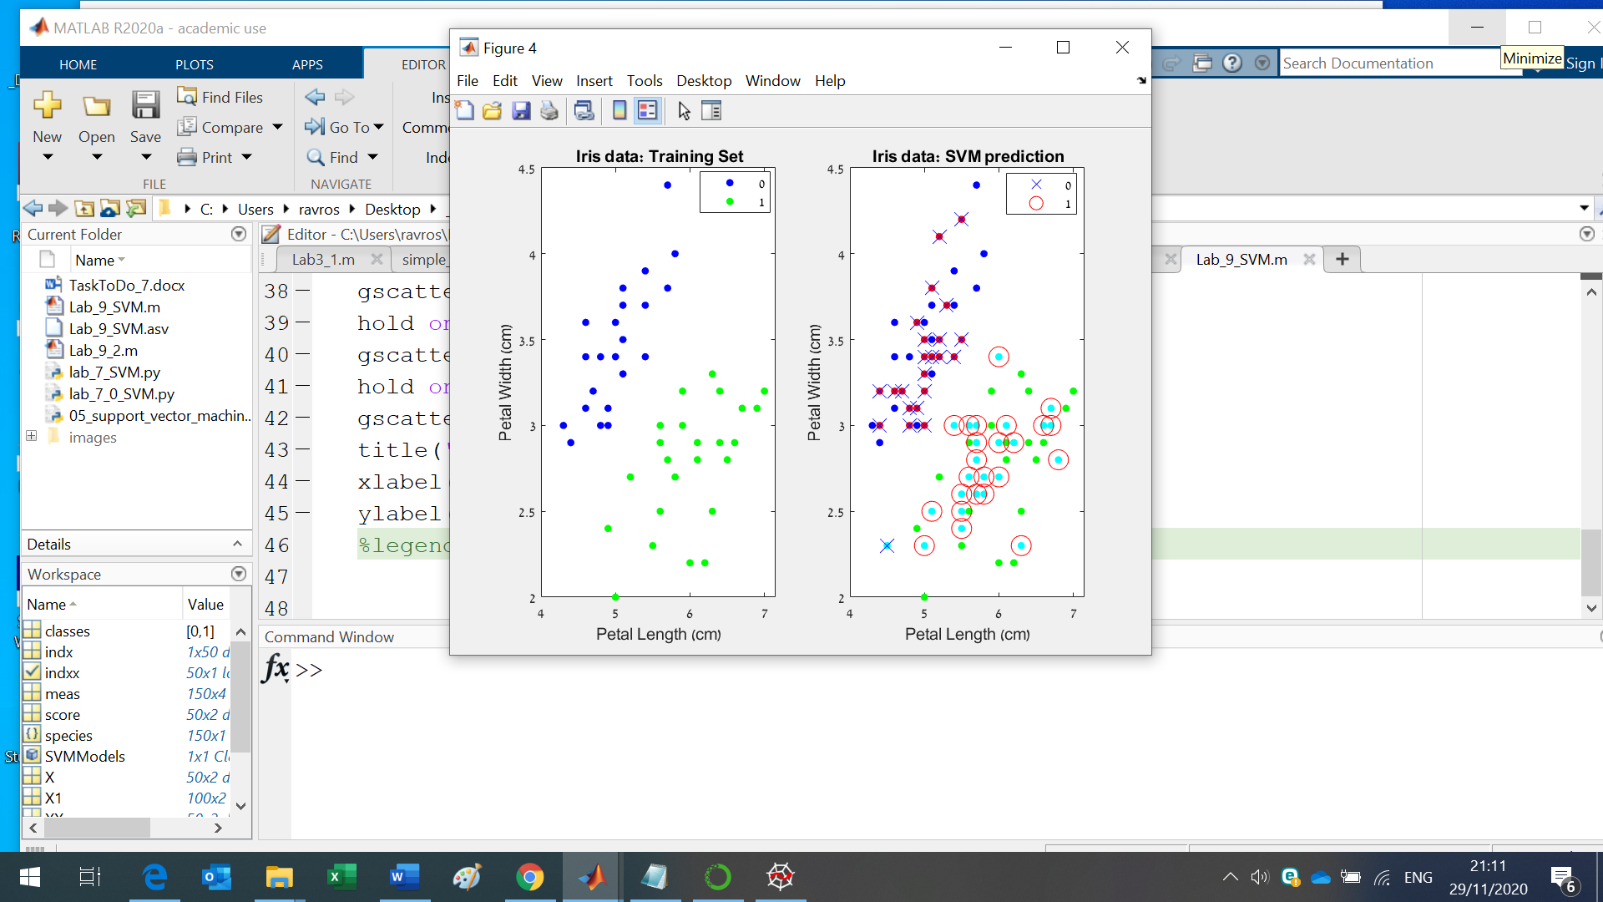

1. Compare the SVM partitioning results with the true labeling. (TP, FN, FP and TN).
2. Calculate the True Positive rate, False Positive Rate, Accuracy and Precision. (see the Lab_5)
3. Open the file lab5_02.py and read the code. Simulate 2 new sets of points with two classes.
4. Verify the model received in 4. on the new sets.
5. Show the SVM partitioning results via different colors and signs like in 5.
6. Compare the SVM partitioning results with the true labeling. (TP, FN, FP and TN).
7. Calculate the True Positive rate, False Positive Rate, Accuracy and Precision.